Optima poultry private limited laboratory is a comprehensive Animal healthcare diagnostic facility, with consultations under one roof.  It prides of housing the latest infrastructure, the best possible diagnostic facilities, accompanied with the most competitive prices and thorough at most care so that the clients can have the diagnostic tests done at the most efficient and cost effective means at a single point by our experienced and certified Veterinarians and friendly supportive staff. We strive to provide ultimate diagnostic services to our clients with accurate results, highest quality tests and comprehensive managemental services with complete care, courtesy and compassion to our customers.

Optima poultry private limited laboratory provides diagnostic solutions that improve animal health and ensure consumer satisfaction. Optima Laboratory is determined to continue to play a pioneering role by innovating and designing the diagnostics of the future to address the major challenges for animal health.

**VISION**

**Quality of Animal Healthcare at affordable cost**

**MISSION**

To improve Animal health and well-being through reliable and accurate diagnostic tests keeping pace with the up-to-date development in veterinary industry.

**OUR SERVICES**

* Chemical Analysis
* Clinical pathology
* Microbiology
* Histopathology
* Other Diagnostic Services

Optima Laboratory offers more than 300 different tests and special profiles in pathology and diagnostic services. We believe one of the most important facets of being an outstanding reference laboratory is the quality assurance we provide in every result. Whether you are seeking a second opinion, need help with result interpretation, or are simply looking for guidance as to the next steps, our professional team of certified specialists is available to assist you.

Optima Laboratory is one of the leading diagnostics center in Coimbatore. We pride on our state-of-the art equipment and expert Veterinary professionals along with trained and experienced technician and lab attendants. We are one of the best diagnostic centers in the city providing precise and accurate diagnostic services. We provide our customers with a whole new experience of diagnostics by providing good ambience and comfort during their visit to our laboratory.

We focus on a quality control system that ensures reliable results and accurate measurements and interpretations every time. We maintain high standards of accuracy in diagnostics using the latest technology developments in veterinary field. Customer satisfaction and specific clinical benchmarks are the measures to compare the quality of a diagnostic laboratory and we at Optima poultry private limited Laboratory have achieved both.

We keep our staff well-trained and updated on the latest developments in our field and ensure that our entire workforce adheres to best laboratory practices. We constantly strive to be the quality service provider leveraging technology and delivering the best to the veterinary society at large.

Our business practices are guided by the highest ethical standards of truth, integrity and transparency. We are fair, sincere and ethical in all our deals to create an environment of trust and respect.

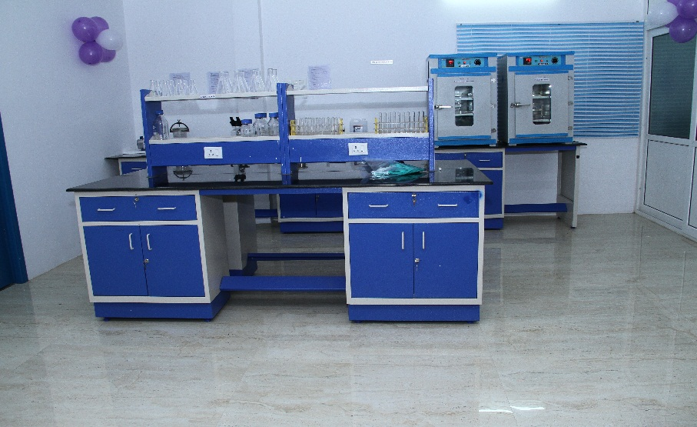Our Scope of Analysis is given below,

**Chemical Analysis:**

**(Feed & Feed Ingredients)**

* Moisture
* Crude Protein
* Crude Fiber
* Crude Fat
* Sand & Silica
* 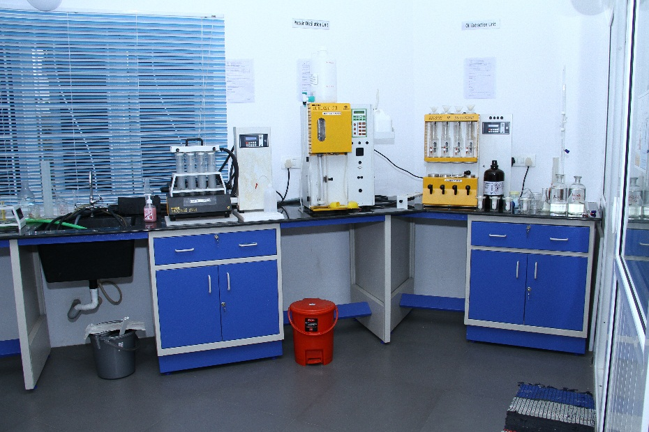T.Ash
* Calcium
* Phosphorous
* Salt (as NaCl)
* Water Analysis (pH, T.D.S, T.H)
* p H.
* Total Dissolved Solids.
* Total Hardness.
* Urease Activity.
* Soluble Protein.
* 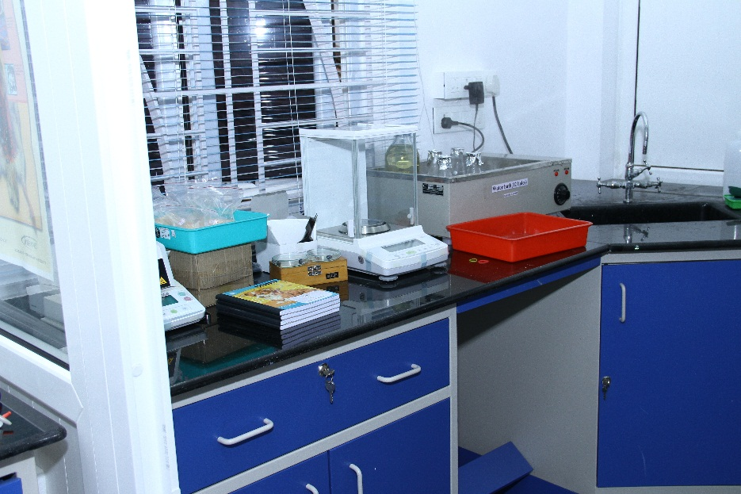Non Protein Nitrogen.
* Pepsin Digestibility.
* Protein Dispensability.
* Free Fatty Acid.(FFA)
* Peroxide Value.(P.V)
* Rancidity Test.
* Leather Meal Test.
* Decomposition
* Iodine Value.
* Thiram Test in Maize.
* Urea In feed samples.
* Co-efficient variation –Mixer C.V test.

Sample Size: **Feed and Feed Ingredients - 250g**, **Other Samples (Oil & Minerals) 100g.**

All samples covered in, clean air tight bag, with clearly mentioned Labels and marks.

Oil sample covered with Container.

Mineral Sample covered with Double air tight bag,

Samples are collect from Maximum Bags (**Composite Sample**)

**Composite Sampling Procedure:**

* Raw Materials: For all poultry raw materials sampling should be Maximum number of bags.

Example;

If lot size 500 bags take at least 50 bags samples.

If lot size 300 bags take at least 30 Bags samples.

* For MBM & Dry Fish sample should covered Double air tight Bags avoid Cross Contamination.
* Feed Samples : For any kind of Feed sample, take maximum number of Bags

Into clear airtight bag with Proper Labeling.

* For any kind OIL sample take from tank, First run 5min, then collect Oil sample in a clean air tight Container avoid leakages.

**Based on sampling only Report gives Accuracy, so kindly concentrate while sample sending**

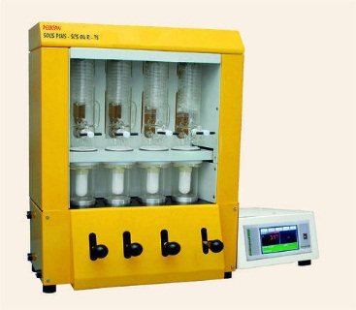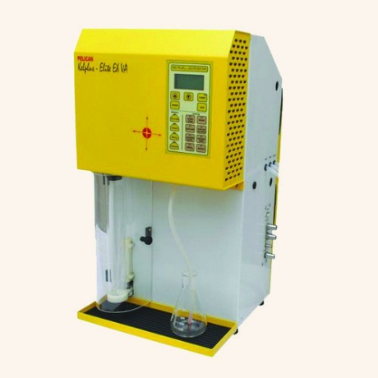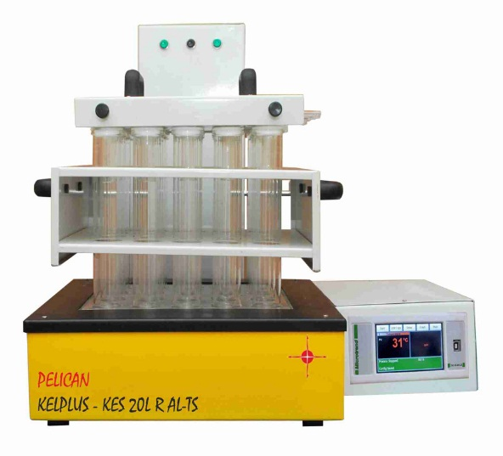**Sample Accuracy gives Reports Accuracy**

